|  |  |
| --- | --- |
| GEN AI LEARNING  **Complete Generative AI Learning – New Year Challenge** | WRITTEN BY: ALOY |

***Day – 5***

**Structured Output Generation using LLM:**

Generating **structured outputs** from a Large Language Model (LLM) has several key benefits, depending on the context and use case. Here’s an overview of why structured output is important:

**1. Improved Usability**

Structured outputs (like JSON, XML, or tabular formats) make it easier for downstream systems or users to process and use the results effectively. For example:

* **Use Case:** Data pipelines or APIs need well-defined outputs to feed into other systems.
* **Benefit:** Avoids the need for post-processing or cleanup of free-text responses.

**2. Accuracy and Consistency**

Unstructured outputs may lead to ambiguity or inconsistency in interpretation. Structured outputs enforce a predefined schema, ensuring:

* **Consistency in Data Representation:** Ensures responses match expectations, reducing errors.
* **Example:** If the expected output is { "name": "John", "age": 25 }, a structured response ensures fields are present and correctly labeled.

**3. Automation and Integration**

In many applications, outputs from an LLM need to be integrated with other tools, databases, or workflows.

* **Example:** A chatbot querying an inventory system can provide the result in JSON format for easy parsing.
* **Benefit:** Automates workflows without requiring additional development to parse free text.

**4. Scalability**

When scaling LLM usage across multiple systems or teams, structured outputs reduce the effort required for standardization.

* **Example:** A customer support system can handle thousands of queries with structured outputs for predefined fields like issue_type, urgency, and customer_id.

**5. Error Reduction**

Structured formats enable validation and error-checking mechanisms, such as ensuring required fields are present or values fall within acceptable ranges.

* **Benefit:** Reduces misunderstandings or downstream failures caused by missing or incorrect data.

**6. Enhanced Machine-to-Machine Communication**

In cases where LLMs interact directly with other systems (e.g., generating SQL queries, formulating API calls, or returning structured data for dashboards), structured formats are crucial.

**Example:** An LLM generating a SQL query might output:

{

"query": "SELECT * FROM customers WHERE age > 30",

"error_check": false

}

**7. Customization for Domain-Specific Applications**

Structured output can conform to the domain-specific requirements of an application, making it highly specialized.

* **Example:** In medical applications, the output might follow a schema for symptoms, diagnosis, and recommended tests.

**8. Facilitates Evaluation and Feedback**

In research or deployment scenarios, structured outputs make it easier to evaluate LLM performance:

* **Benefit:** Metrics can be easily calculated on the structured output.
* **Example:** Comparing actual vs. expected fields or values in an AI-generated response.

**Conclusion**

Structured outputs enhance **efficiency**, **reliability**, **interoperability**, and **scalability**, making them indispensable for real-world LLM applications. They bridge the gap between the creative, freeform nature of LLMs and the rigid, deterministic requirements of computational systems.

Below is the code,

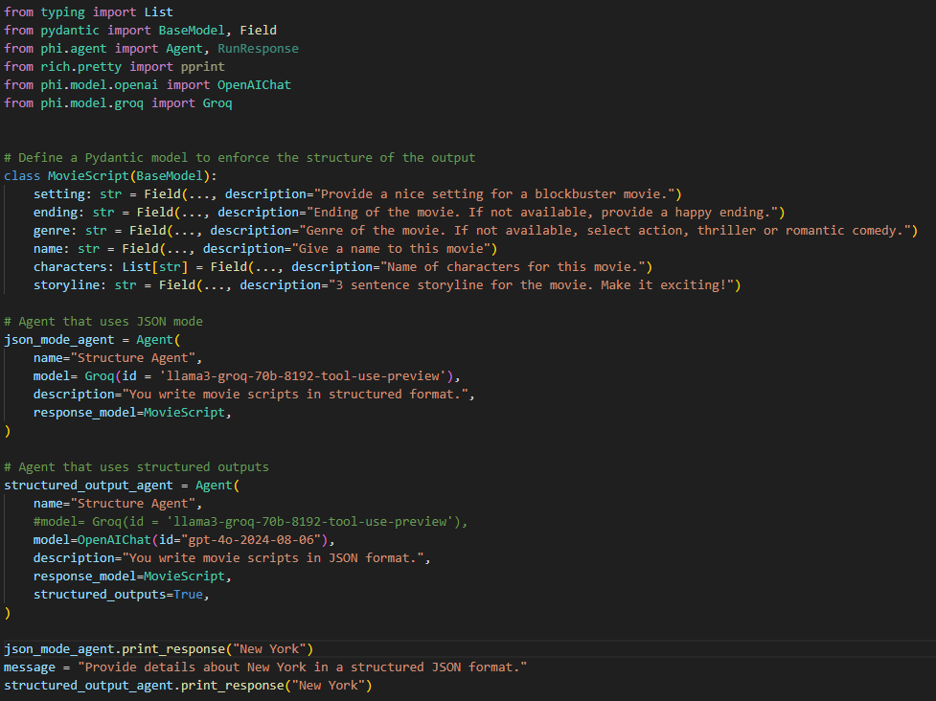

Response:

